Subscriptions for next term will remain at £30

Next term – 13th Sept to 5th December, 2017
Half term 2 weeks – 18th/25th October

Next Year term starts 10th January , 2018

The Summer Term kicked off with the Beavers joining the Cubs and Scouts with the annual St George’s Day Parade in Dorchester. As ever there was an excellent turn out and the sun shone on a fantastic day.
We have also been lucky enough to have Maxwell’s dad, Tim Dellor, lead a cricket coaching session. As well as being a presenter on BBC Radio Berkshire, Tim is also an ECB qualified coach so the Beavers could not have been in better hands.
We have also been making bird feeders at Zac’s grandparents’ house, having a go growing some cress and planting flowers in the baskets at the Pavilion.
We have invested Tilly, Jamie, Noah, Edward and Hattie into our Beaver colony in time for the highlight of the year which is the Fun Day and Family Camp held at Tarka’s home. In addition, we went to the Dolphin Centre in Pangbourne for some fun on the river and we had a go in their Bell Boats (two kayaks attached to each other). A good time was had by all.

This week we say goodbye to Barney, Benedict and Maxwell and break up for summer.

This term also marked a significant milestone and end of an era as Julia Barry a.k.a. Tarka hangs up her woggle and scarf after 23 years! Everyone who has either been a Beaver or the parent of one will agree that Julia’s dedication and enthusiasm has been incredible. We are fortunate to be welcoming two new leaders, Emma and Tracey to join Mufasa and Nala to try and fill the very big shoes Julia is leaving us.

Bronze awards were awarded to Barnaby, Benedict and Maxwell. Well done to them all, who worked so hard for these awards, and good luck to them in Cubs.

For further details about Stoke Row Beavers, please contact Carly Hunt at
carlynut55@googlemail.com

What a brilliant term we’ve had, lighting fires, playing games in the woods, shelter building, biking, map-reading and working towards our World Challenge badge! In fact, we really didn’t need the summer term to get any better – but it did, because this year Stoke Row Cubs are the district go-karting champions! Yay!
Since then, we’ve had an incredible time camping at Longridge (near Marlow), where we had a jam-packed weekend doing so many things… Dragon boating, bell-boating, kayaking, sailing, climbing, doing the giant swing, laser tagging, singing songs around the campfire, playing games – you name it, we probably did it!
Then last week we had a terrific visit to RAF Benson, learning all about Chinooks and Pumas, and earning our Air Activities level 3 badge, which was awarded by Wg Cdr Marty D Lock and Station Commander Hamish Cormack (better known to us as James and Chloe’s dad!). Great stuff!
In between all our activities this term, we have been delighted to welcome Max, Angus, Samuel and Henry to the worldwide family of scouting. They have all settled in brilliantly and are doing really well!
But sadly, it’s now time to say farewell to our oldest Cubs, who have now turned 11, but will all be leaving having achieved their Chief Scout Silver award! A huge ‘well done’ to Joseph, James C, Chloe, Phoebe, Louisa, Rhian, Max, Matilda and Alexander – and many thanks for all you have done for Stoke Row Cubs!

For further details about Stoke Row Cubs please contact Jan Seal-Roberts (Akela) at
jan.seal-roberts@springer.com

This term Huw has been joined by Emma Alvey, who will help full time from September. Clare has been unable to help this term, but should be back for September. We now have 19 Scouts, of whom 5 are girls.

We have had a busy term, outdoors as usual, Activities have included tent pitching, ice cream making (messy), making sledges, night hikes and cycling.

Group Family fun night and BBQ

We all enjoyed the Group Family fun night and BBQ, held on the hottest day of the year. There were lots of activities to amuse all ages, and the water games proved very popular. Thanks to all parents who helped on the BBQ, selling drinks and helped with activities. Without parental volunteers, the Scout Group would not be able to provide such great events for our young people.
Goodbye to Tarka!
A very special guest, Michael Macfadyen, Deputy Lord Lietenant for Oxfordshire, led the tributes to Tarka at the Family Fun Night.
He recounted how she has been leading the Beavers, first as an assistant, then as Leader for 23 years. Over that time, it was calculated that she has had an influence on over 1000 young people.
He continued:
Her enthusiasm is infectious and she is always passionate about giving the youngsters new experiences. She has led them on night hikes, bike rides, camps (mostly in her own garden), awarded countless badges, led creative tasks, taught nature, astronomy, pet care, ornithology, horticulture and countless other life skills. She has inspired them and had fun with them and of course she has done all that good stuff behind the scenes like DBS checks for helpers and all the less glamorous admin tasks and she has done it all with the biggest smile on her face and has never once been heard to say “No - we can’t do that''. She is always positive and constantly looks for new and exciting challenges to tackle.

Mike, the Group Scout Leader, also added his sincere thanks on behalf of the Group.
Finally, Tarka was presented with a bench for her garden, and a photo book of memories, by Robin, the incoming Beaver Leader.
Below is a Thank you from Julia.
Dear Scout Group,

Thank you so much for my lovely send off last night and all the very kind words from Mike and our special guest Michael Macfadyen. 23 years really has gone very quickly – it shows how much I have enjoyed it. I am thrilled with my gifts – I tested the bench this morning and it looks perfect at the bottom of our garden beside the field which is a beautiful meadow of grasses at the moment and the very special Photograph album of the Beavers I shall really treasure along with the card. Robin and Jackie did a brilliant and very time consuming job putting that album together. I am so pleased to know that the Colony is remaining in such good hands with Robin at the helm and Jenny, Emma L, Tracey, Carly and Kerrie helping and I know it will continue to go from strength to strength.
I have many happy and funny and memories of the Beavers over the years and it is lovely when I see them around as maturing young men and women.

You have not seen the back of me yet! I shall be around to help the new Leaders settle in and from time to time in the future if extra help is needed.

I would welcome any photos any of you took last night please!
With much thanks and love
Julia aka Tarka

Wishing you all a great Summer, see you in September!
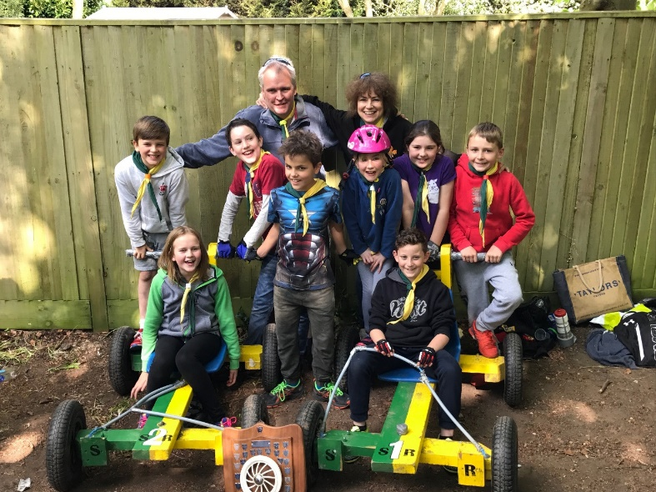
The Victorious Cub Go-Kart team
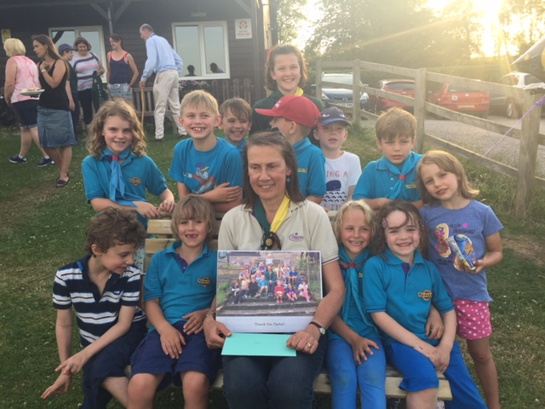
Tarka and some of the current Beavers

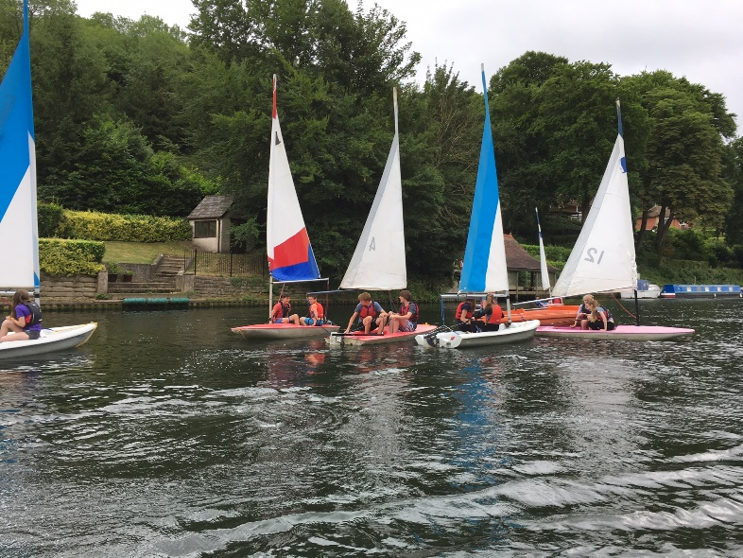
Scouts enjoying Sailing at Longridge Camp
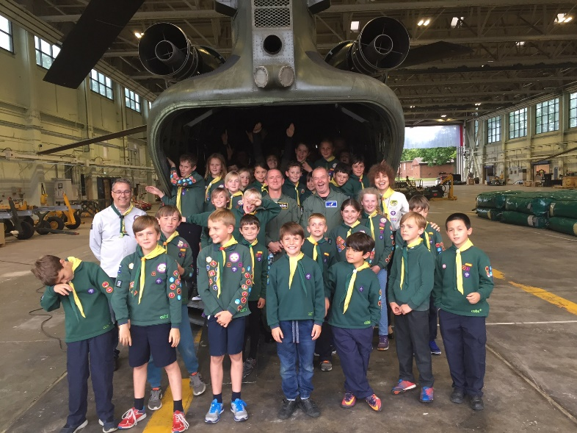
Cubs with Station Commander Hamish Cormack at RAF Benson
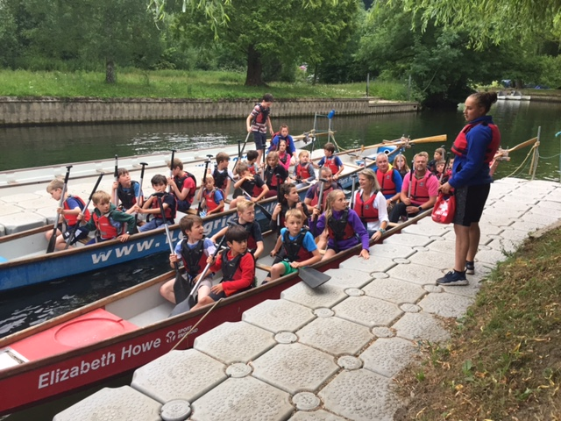
Cubs in the Dragon boats at Longridge

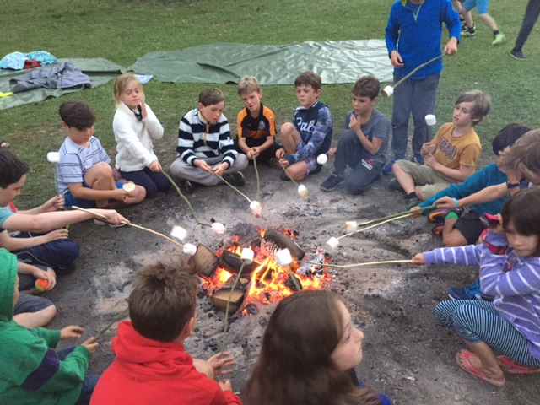
Toasting marshmallows – the perennial favourite!

